**Lesson 4 Demo 1**

**Understanding the Working of Deployments**



Steps to be followed:

1. Creating a deployment
2. Checking the status of the deployment

**Step 1: Creating a deployment**

1. Create a namespace using the command:

***kubectl create namespace test***

| **Note:**If the **test** namespace is already created, ignore **Step 1.1.** |
| --- |



1. Create a deployments folder:

***mkdir deployments***

***cd deployments***



1. Open facebookdeployment.yaml:

***vi facebookdeployment.yaml***



1. Copy the following code in the yaml file:

***---***

***apiVersion: apps/v1***

***kind: Deployment***

***metadata:***

***name: mynginx***

***namespace: test***

***spec:***

***strategy:***

***type: RollingUpdate***

***rollingUpdate:***

***maxSurge: 4***

***maxUnavailable: 1***

***revisionHistoryLimit: 4***

***paused: false***

***replicas: 2***

***minReadySeconds: 10***

***selector:***

***matchLabels:***

***role: webserver***

***jane: akil***

***matchExpressions:***

***- {key: version, operator: In, values: [v1, v2, v3]}***

***template:***

***metadata:***

***name: web***

***labels:***

***role: webserver***

***version: v1***

***tier: front***

***jane: akil***

***spec:***

***containers:***

***- name: nginx***

***imagePullPolicy: IfNotPresent***

***image: nginx***

***ports:***

***- containerPort: 80***

***protocol: TCP***

***resources:***

***requests:***

***memory: "100Mi"***

***cpu: "250m"***

***limits:***

***memory: "128Mi"***

***cpu: "300m"***

***---***

***apiVersion: v1***

***kind: Service***

***metadata:***

***name: web-service***

***namespace: test***

***labels:***

***role: web-service***

***spec:***

***selector:***

***role: webserver***

***type: NodePort***

***ports:***

***- port: 80***

***nodePort: 32003***

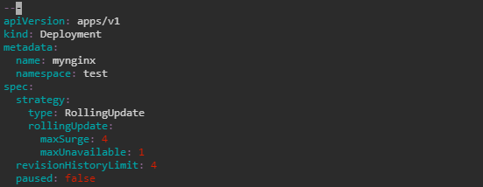

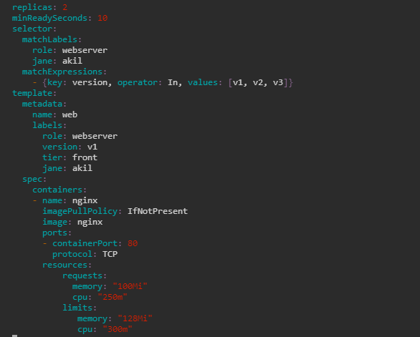

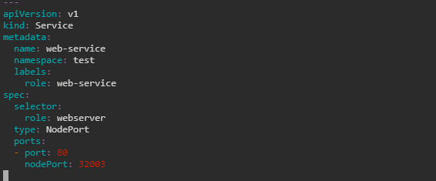

| **Note:** Press **esc** button and type **:wq** to save the file. Check the version: apiversion should be **v1.** |
| --- |

1. Run the following command before checking the status of the deployment:

***kubectl apply -f facebookdeployment.yaml***

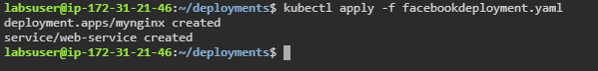

**Step 2: Checking the status of the deployment**

1. Execute the following command to check the status of the deployment:

***kubectl rollout status deployment/mynginx -n test***

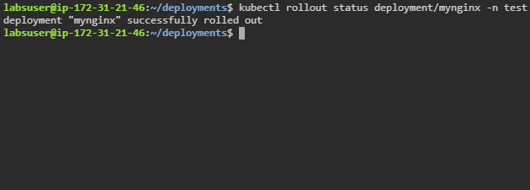

| **Note:** If an error of taint node appears, follow the commands to make the node untainted:  ***kubectl taint nodes <master node name> node-role.kubernetes.io/master-***  Re-execute from step 1.5 to get the desired output of rollout status. |
| --- |